**Coordinate Geometry**

# Coordinate axes:

Two perpendicular number lines intersecting at point zero are called **coordinate axes**. The point of intersection is called **origin** and denoted by ‘*O*’. The horizontal number line is the ***x*-axis** (denoted by *X’OX*) and the vertical one is the ***y*-axis** (denoted by *Y’OY*).

1. **Cartesian plane** is a plane formed by the coordinate axes perpendicular to each other in the plane. It is also called as *xy* plane.

The axes divide the Cartesian plane into four parts called the **quadrants** (one fourth part), numbered I, II, III and IV anticlockwise from *OX*.

# Coordinates of a point:

* + The x-coordinate of a point is its perpendicular distance from *y*-axis, called **abscissa.**
  + The y-coordinate of a point is its perpendicular distance from *x*-axis, called **ordinate**
  + If the abscissa of a point is *x* and the ordinate of the point is *y*, then (*x, y*) is called the **coordinates**

of the point.

* + The point where the *x*-axis and the *y*-axis intersect is represented by the coordinate point (0, 0) and is called the **origin**.

# Sign of the coordinates in the quadrants:

Sign of coordinates depicts the quadrant in which it lies.

* + The point having both the coordinates positive i.e. of the form (+, +) will lie in the first quadrant.
  + The point having x-coordinate negative and y-coordinate positive i.e. of the form (-, +) will lie in the second quadrant.
  + The point having both the coordinates negative i.e. of the form (-, -) will lie in the third quadrant.
  + The point having x-coordinate positive and y-coordinate negative i.e. of the form (+,-) will lie in the fourth quadrant.

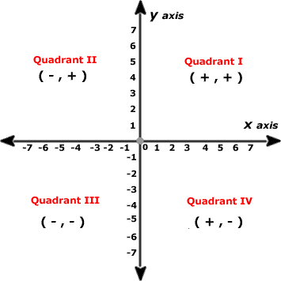

# Coordinates of a point on the x-axis or y-axis:

The coordinates of a point lying on the *x*-axis are of the form (*x*, 0) and that of the point on the *y*-axis are of the form (0, *y*).

# Distance formula

The distance formula is used to find the distance between two any points say *P(x1, y1*) and *Q*(*x2, y2*)

which is given by: *PQ*  (*x*  *x* )2  (*y*  *y* )2 .

2 1 2 1

* + The distance of a point P(x, y) from the origin O(0, 0) is *OP* 
  + The points *A, B* and *C* are **collinear** if *AB + BC = AC*.

*x*2  *y* 2 .

# Determining the type of triangle using distance formula

1. Three points *A, B* and *C* are the vertices of an **equilateral triangle** if *AB = BC = CA*.
2. The points *A, B* and *C* are the vertices of an **isosceles triangle** if *AB = BC or BC = CA or CA = AB*.
3. Three points *A, B* and *C* are the vertices of *a* **right triangle** if the sum of the squares of any two sides is equal to the square of the third side.

# Determining the type of quadrilateral using distance formula

For the given four points A, B, C and D, if:

1. *AB = CD, BC = DA; AC  BD*  *ABCD* is a parallelogram.
2. *AB = BC = CD = DA; AC  BD*  *ABCD* is a rhombus
3. *AB = CD, BC = DA; AC = BD*  *ABCD* is a rectangle
4. *AB = BC = CD = DA; AC = BD*  *ABCD* is a square.

# Circumcentre of a triangle

The point of intersection of the perpendicular bisectors of the sides of a triangle is called the

**circumcentre**. In the figure, O is the circumcentre of the triangle ABC.

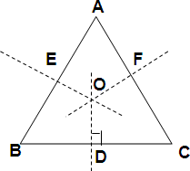

* + Circumcentre of a triangle is equidistant from the vertices of the triangle. That is, ***P* is the circumcentre of**  ***ABC*, if *PA* = *PB = PC***.
  + Moreover, if a circle is drawn with *P* as centre and PA or PB or PC as radius, the circle will pass

through all the three vertices of the triangle. *PA* (or *PB* or *PC*) is said to be the **circumradius** of the triangle.

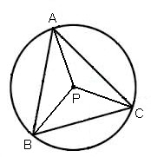

# Section formula

If *P* is a point lying on the line segment joining the points *A* and *B* such that *AP: BP* = *m: n.* Then, we say that the **point *P* divides the line segment *AB* internally** in the ratio *m: n*.

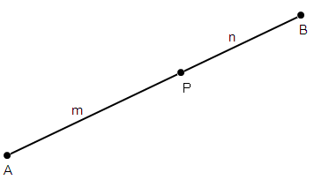

Coordinates of a point which divides the line segment joining the points (*x1, y*1) and (*x2, y2*) in the ratio

*m*: *n* internally are given by:

 *mx*2  *nx*1 , *my*2  *ny*1 

 *m*  *n m*  *n* 

 

This is known as the **section formula**.

1. If *P* is a point lying on *AB* produced such that *AP: BP* = *m: n*, then point ***P* divides *AB* externally** in the ratio *m: n*.

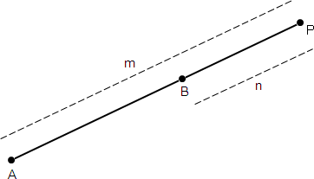

If *P* divides the line segment joining the points A (*x*1, *y*1) and *B* (*x*2, *y*2) in the ratio *m*: *n* externally, then the

coordinates of point *P* are given by  *mx*2  *nx*1

, *my*2  *ny*1  .

 *m*  *n m*  *n* 

 

# Coordinates of Mid-point

Mid-point divides the line segment in the ratio 1:1. Coordinates of the mid-point of a line segment joining the points (*x1, y*1) and (*x2, y2*) are

 *x*2  *x*1 , *y*2  *y*1  .

 2 2 

 

# Centroid of a triangle

The point of intersection of the three medians of a triangle is called the centroid.

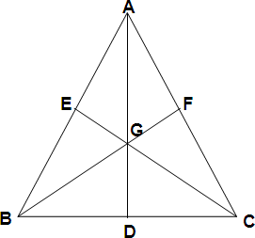

In the figure, G is the centroid of the triangle ABC where AD, BF and CE are the medians through A, B and C respectively.

Centroid divides the median in the ratio of 2:1.

# Coordinates of the centroid

If *A*(*x1, y1*), *B*(*x2, y2)* and *C*(*x3, y3*) are the vertices of a triangle ABC, then the **coordinates of the centroid** are given by

*G* =  *x*1  *x*2  *x*3 , *y*1  *y*2  *y*3 

 3 3 

 

# Incentre of a triangle

The point of intersection of all the internal bisectors of the angles of a triangle is called the **incentre**.

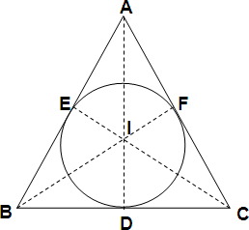It is also the centre of a circle which touches all the sides of a triangle (such type of a circle is named as the incircle).

In the figure, *I* is the incentre of the triangle ABC.

# Coordinates of incentre

If *A(x1, y*1), B(*x2, y*2) and *C(x3, y*3) are the vertices of a triangle, then the **coordinates of incentre** are given by

*I* =  *ax*1  *bx*2  *cx*3 , *ay*1  *ay*2  *ay*3 

 *a*  *b*  *c a*  *b*  *c* 

 

# Orthocentre of a triangle

The point of intersection of all the perpendiculars drawn from the vertices on the opposite sides (called altitudes) of a triangle is called the **Orthocentre** which can be obtained by solving the equations of any two of the altitudes.

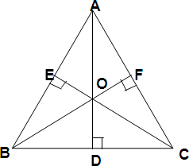

In the figure, O is the orthocentre of the triangle ABC.

1. If the triangle is equilateral, the centroid, the incentre, the orthocenter and the circumcentre coincides.
2. Orthocentre, centroid and circumcentre are always collinear, whereas the centroid divides the line joining the orthocentre and the circumcentre in the ratio of 2:1.

# Area of a triangle

If *A*(*x*1*, y*1)*, B*(*x*2*, y*2) and *C*(*x*3*, y*3) are the vertices of a triangle, then the **area of triangle** ABC is given

by 1 *x* (*y*  *y* )  *x* (*y*  *y* )  *x* (*y*  *y* ).

2 1 2 3 2 3 1 3 1 2

* + Three given points are **collinear**, if the **area of triangle formed by these points is zero.**

# Area of a quadrilateral

Area of a quadrilateral can be calculated by dividing it into two triangles.

Area of quadrilateral ABCD = Area of

*ABC*

+ Area of

*ACD*

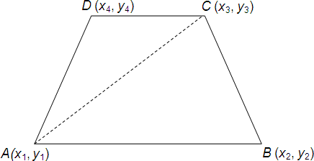

Note: To find the area of a polygon, divide it into triangular regions having no common area, then add the areas of these regions.